Business Question and Visualization Report

Date: 30 July 2025

ID: SWUID20250188226

Project Name: Global Food Production Trends

Project Title: Analysis of Global Food Production (1961–2023)

Maximum Marks: 5 Marks

**1) What is the total global wheat and rice production from 1961 to 2023?**

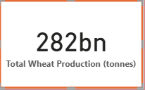  
**Visualization:**

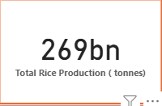

**2) Which countries are the top producers of green coffee globally?**

**Visualization:**

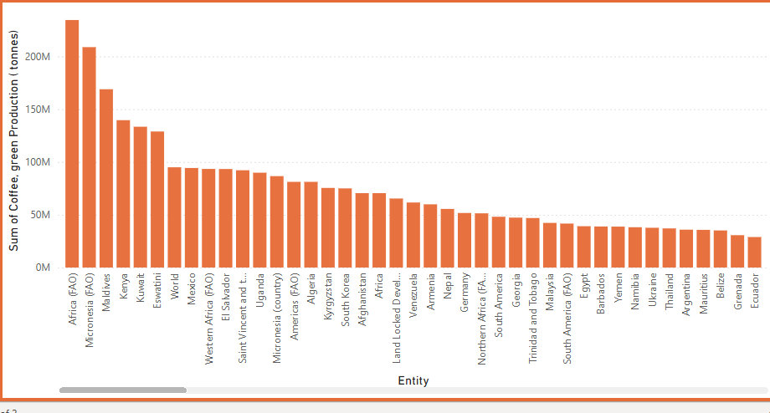

**3) How has wheat and rice production changed over time globally?**

**Visualization:**

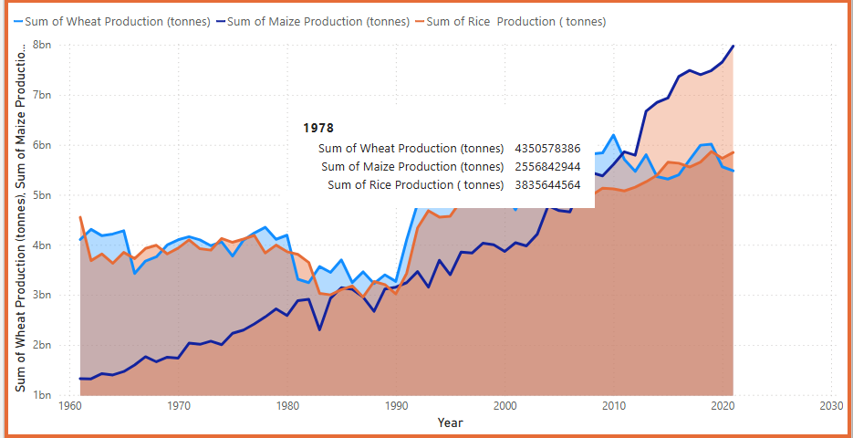

**4) Which year recorded the highest maize production contribution?**

**Visualization:**

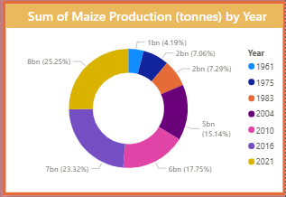

**5) What is the total tea production during the analysis period?**

**Visualization:**

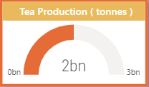

.

**6) Which countries contribute most to banana, apple, orange, avocado, and grape production?**

**Visualization:**

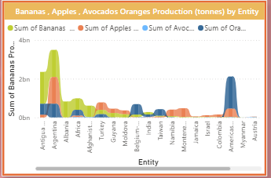

**7) Which year showed a major rise in crop production globally?**

**Visualization:**

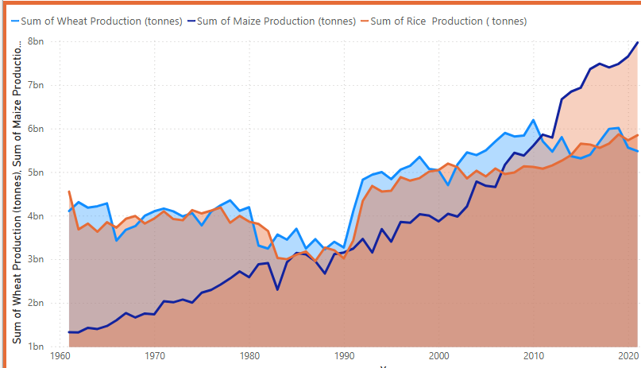

**8) How do individual crops compare in overall production volume?**

**Visualization:**



